EXPERIMENT 1
echo "------------------------------------------------------"
echo "To Identify the Current Shell and Length of the String"
echo "------------------------------------------------------"
echo "The Current Shell is = $SHELL"
echo "------------------------------------------------------"
str1="Welcome to Rathinam College"
echo $str1
len=${#str1}
echo "Length of the String = $len"
echo "------------------------------------------------------"

OUTPUT:

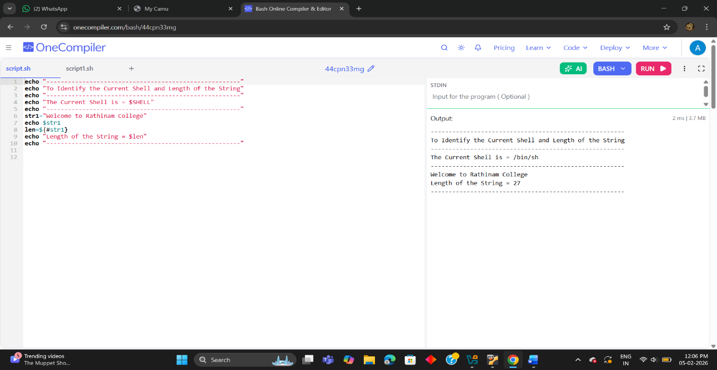
EXPERIMENT 2
echo "----------------------------------------------"
echo "To Count Backwards for 100 to 0 Using For Loop"
echo "----------------------------------------------"
c=0
for (( i =100; i >= 0; --i ))
do
echo "$i"
s=$[c++]
done
echo "----------------------------------------------"
echo "Count = $s"
echo "----------------------------------------------"

OUTPUT:

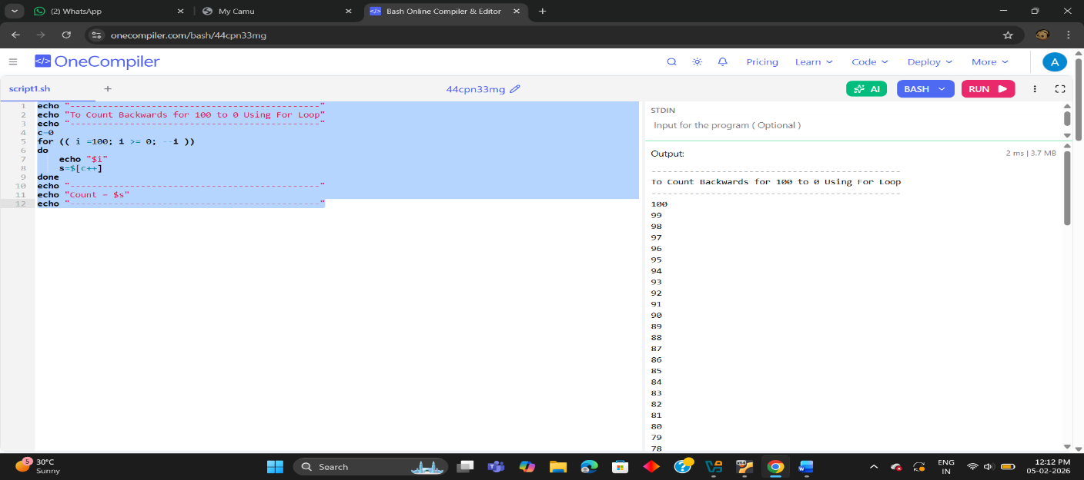
EXPERIMENT 3
echo "To print * in Decending order using for loop"
echo "____________________________________________"
for ((i=5; i>=1; i--))
do
for ((j=1; j<=i; j++))
do
echo -n "*"
done
echo
done
echo "____________________________________________"

OUTPUT:

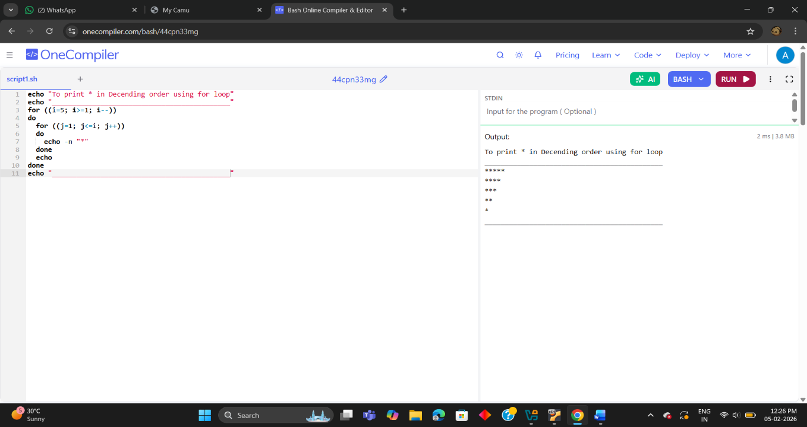
EXPERIMENT 4
echo "__________________________________________________________"
echo "To print even and odd numbers and their count and sums"
echo "__________________________________________________________"

even_count=0
odd_count=0
even_sum=0
odd_sum=0

echo "Even numbers from 0 to 100:"
for (( i=0; i<=100; i++ ))
do
if (( i % 2 == 0 )); then
echo -n "$i "
((even_count++))
((even_sum+=i))
fi
done

echo -e "\n\nOdd numbers from 0 to 100:"
for (( i=0; i<=100; i++ ))
do
if (( i % 2 != 0 )); then
echo -n "$i "
((odd_count++))
((odd_sum+=i))
fi
done

echo -e "\n\n--------------------------"
echo "Even numbers count = $even_count"
echo "Even numbers sum = $even_sum"
echo "Odd numbers count = $odd_count"
echo "Odd numbers sum = $odd_sum"

OUTPUT:
